## CROWD MONITORING

*Report submitted to the SASTRA Deemed to be University as requirement for the course*

### ECE300:MINI PROJECT

*Submitted by*

**Arulpalaniappan.A(Reg. No.: 124004030)**

**Hareesh Aravind.R.G(Reg.No.: 124004092)**

# May 2023



**SCHOOL OF ELECTRICAL & ELECTRONICS ENGINEERING**

### THANJAVUR, TAMIL NADU, INDIA – 613 401



### SCHOOL OF ELECTRICAL & ELECTRONICS ENGINEERING THANJAVUR – 613 401

**Bonafide Certificate**

This is to certify that the mini project titled “Crowd monitoring system using IR sensor” was submitted in partial fulfillment of the requirements for the award of the degree of B. Tech. Electronics & Communication Engineering to the SASTRA Deemed to be University, is a bonafide record of the work done by **Mr**. **ARULPALANIAPPAN.A (Reg. No.: 124004030), MR. HAREESH ARAVIND R.G(Reg. No.: 124004092),** during the final semester of the academic year 2022- 23, in the **School of Electrical & Electronics Engineering**, **Electronics and Communication Engineering**, under my supervision. This thesis has not formed the basis for the award of any degree, diploma, associateship, fellowship, or other similar titles to any candidate of any University.

### Signature of Project Supervisor: Name with Affiliation :

**Date :**

Project *Viva-voce* held on

### Examiner 1 Examiner 2



**SCHOOL OF ELECTRICAL & ELECTRONICS ENGINEERING THANJAVUR – 613 401**

**Declaration**

We declare that the thesis titled “**CROWD MONITORING SYSTEM** submitted by US is an original work done by us under the guidance of **MRS NITHYA C, Assistant Professor, School of Electrical and Electronics Engineering, SASTRA Deemed to be University** during the final semester of the academic year 2022-23, in the **School of Electrical and Electronics Engineering**. The work is original and wherever we have used materials from other sources, we have given due credit and cited them in the text of the thesis. This thesis has not formed the basis for the award of any degree, diploma, associate ship, fellowship, or other similar titles to any candidate of any University.

### Signature of the candidate(s) :

**Name of the candidate(s) :**

**Date :**

# Acknowledgements

First of all we express our gratitude to **Prof. Dr S Vaidhyasubramaniam**, Vice Chancellor, SASTRA Deemed University, who provided all facilities and constant encouragement during our study. We extend our sincere thanks **to Prof. R.Chandra Mouli**, Registrar, SASTRA Deemed University for providing the opportunity to pursue this project. It is our privilege to express our sincerest regards to our project coordinator, **Dr. K. Thenmozhi**, Dean (SEEE), **Sridhar K**, Associate Dean (ECE) and **Dr. R. John Bosco Balaguru**, Dean (Sponsored Research) who motivated us during the project.

It is our privilege to express our sincerest regards to our project coordinators, **Dr. R. RAMESH** (ECE/SEEE), who motivated us during the project. We owe a debt of most profound gratitude to our guide **Dr . NITHYA C (ECE/SEEE)** for her valuable inputs, able guidance, encouragement, wholehearted cooperation and constructive criticism throughout our mini project on the topic “**CROWD MONITORING SYSTEM**. We take this opportunity to thank all our lecturers who have directly or indirectly helped our project.

# Abstract

Crowd control refers to the techniques and strategies used to manage large gatherings of people in a safe and efficient manner. This is typically done to prevent the occurrence of potential safety hazards, such as stampedes, riots, and other forms of disorderly conduct that can result in injuries, damage to property, and loss of life. This idea is implemented using a microcontroller DevKit DOIT VI and IR sensor. The main goal here is to detect the number of people entering a particular place. IR sensor takes the responsibility for detecting the count value. This is done by level triggering method. Count is then processed with DevKit DOIT VI .Now an account in ThingSpeak is created with specific API key and Channel ID.ThingSpeak is an opensource application. The processed data from DevKit DOIT VI is finally gets uploaded to ThingSpeak where it will be visible in a user friendly format.

NAME : ARULPALANIAPPAN.A REG.N0.:124004030

NAME : HAREESH ARAVIND.R,G REG.NO.:124004092

SIGNATURE OF GUIDE

### 

|  |  |
| --- | --- |
| Content | Page no. |
| List of figures | 7 |
| Introduction | 8 |
| Methodology | 9 |
| Installation of libraries and boards | 10 |
| Esp32 | 13 |
| Connection of Esp32 and wifi | 14 |
| IR Sensor | 15 |
| Integrating IR sensor and Esp32 | 16 |
| Thingspeak | 17 |
| Integrating Thingspeak with IR sensor and Esp32 | 18 |
| Output | 19 |
| Conclusion | 20 |

### Table of contents

### LIST OF FIGURES

|  |  |
| --- | --- |
| Fig no | Content |
| 1 | Selection of sketch from tools |
| 2 | Searching library from search bar |
| 3 | Ensuring installation |
| 4 | Inbuilt examples |
| 5 | Esp32 |
| 6 | IR sensor |
| 7 | Pin diagram of Esp32 and IR sensor |
| 8 | Account section |
| 9 | Channels in ThingSpeak |
| 10 | Channel Id |
| 11 | API key |
| 12 | Private view |
| 13 | Output |

### INTRODUCTION

Crowd monitoring is the practice of observing and regulating huge crowds, typically in public places or at events. Here are some important crowd monitoring points: Crowd monitoring is critical for guaranteeing the safety and security of persons within a crowd. Potential risks, threats, and incidents can be discovered early by monitoring the crowd, allowing for timely interventions and emergency responses. Crowd Control: Monitoring crowd movement and behaviour aids in the maintenance of order and the control of crowd flow. This includes directing people to exits or designated places, as well as controlling lineups and preventing overcrowding. Emergency Preparedness: Crowd monitoring is critical in emergency preparedness. Authorities can discover potential hazards or threats, such as overcrowding, stampedes, or health issues, by monitoring the crowd. Crowd monitoring is all about collecting data of expected and unexpected crowd occurrences.

### METHODOLOGY

Installation of all the libraries and boards required.

Learning the basic coding required for the system. ie: how to configure input pin etc.

Learning how to connect esp32 to wifi.

Integrating esp32 and IR sensor together.

Creating an account on ThingSpeak with appropriate field names and noting down the unique channel ID and API key.

Processing the value of count ie: assign 1 if object is detected and 0 if not.

Uploading the data to ThingSpeak via esp32.

Esp32

IR sensor

Thingspeak Public View

ThingSpeak API key and Channel ID

**INSTALLATION OF LIBRARIES AND BOARDS**

Proper libraries has to be installed in Arduino IDE in order for the proper compilation and execution.

Wifi library and ThingSpeak library has to be installed.

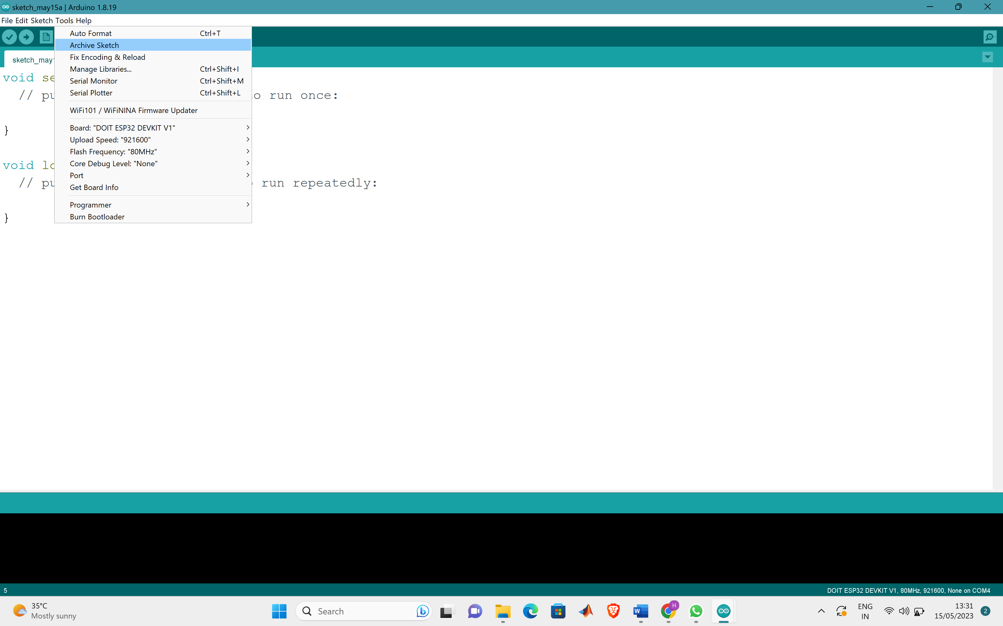

Fig 1:Selection of sketch from tools

In the menu bar, select "Sketch" and then "Include Library" or "Manage Libraries." This launches the Library Manager. You can browse the list of available libraries in the Library Manager. You can find a certain library by name or keyword using the search bar. Once you've located the desired library, click on it to view its details. Check the library's version and read the description to ensure it meets your needs. To begin the installation procedure, click the "Install" button. The library files will be downloaded and installed by the Arduino IDE.

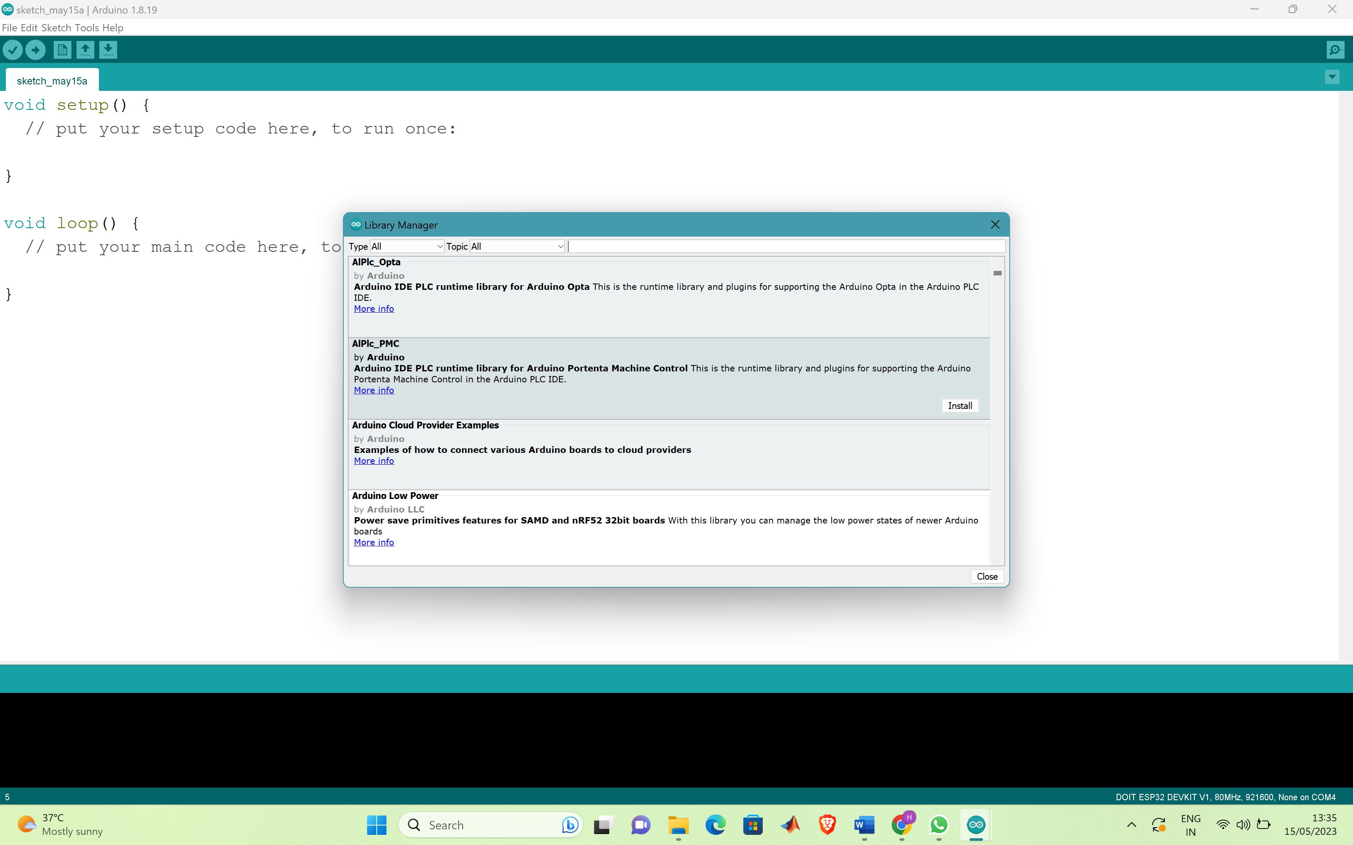

Fig 2:Searching library from search bar

After the libraries are properly installed it is time for us to install the board. Open the Arduino IDE. In the menu bar, select "File" and then "Preferences." This brings up the Preferences window. Find the "Additional Boards Manager URLs" field in the Preferences window and click the icon to the right of it. This will bring up a text entry box. Enter the URL of the board package to be installed. The URL for board packages is often provided by the board maker or community. Make sure you type the entire URL. Close the text input box by clicking the "OK" button, and then click the "OK" button in the Preferences window. Navigate to "Tools" in the menu bar.

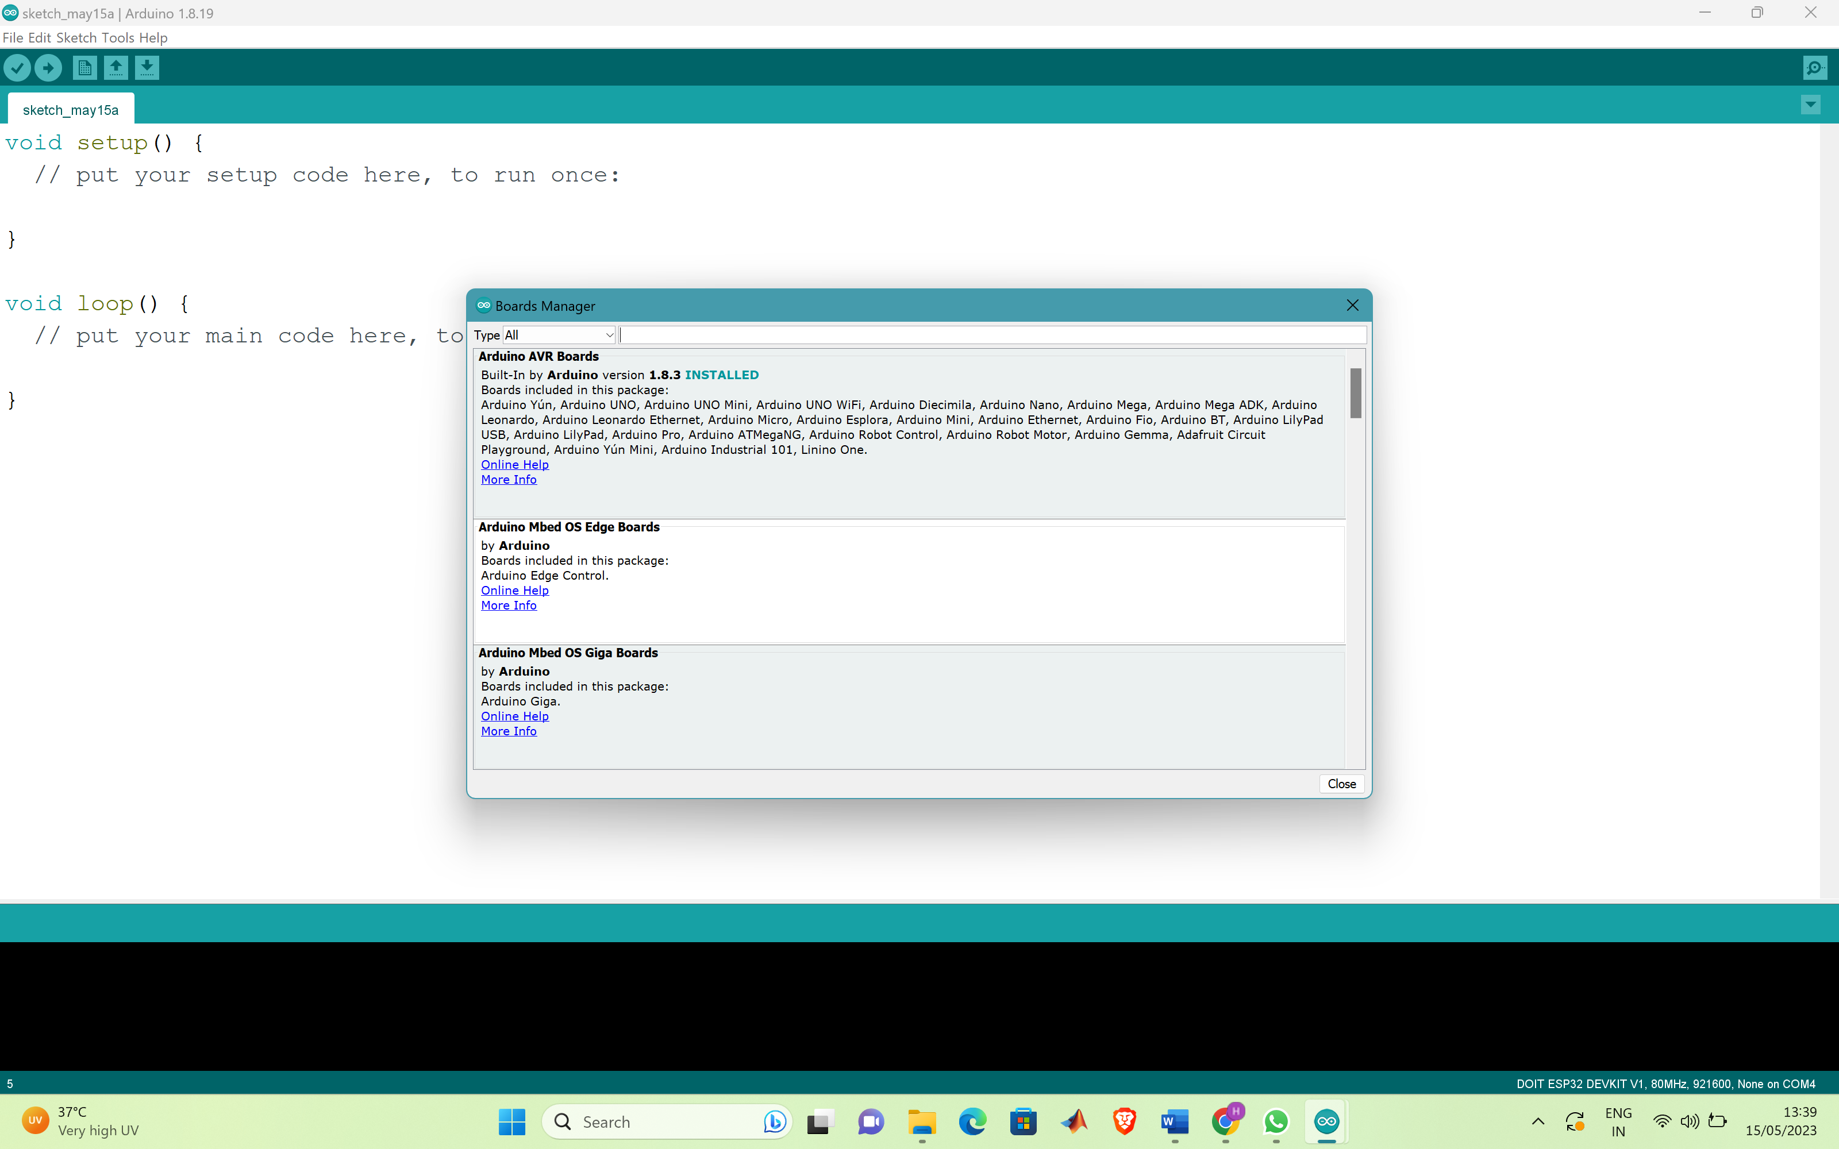

Fig 3:Ensuring installation

We can ensure proper installation by checking any one of the inbuilt examples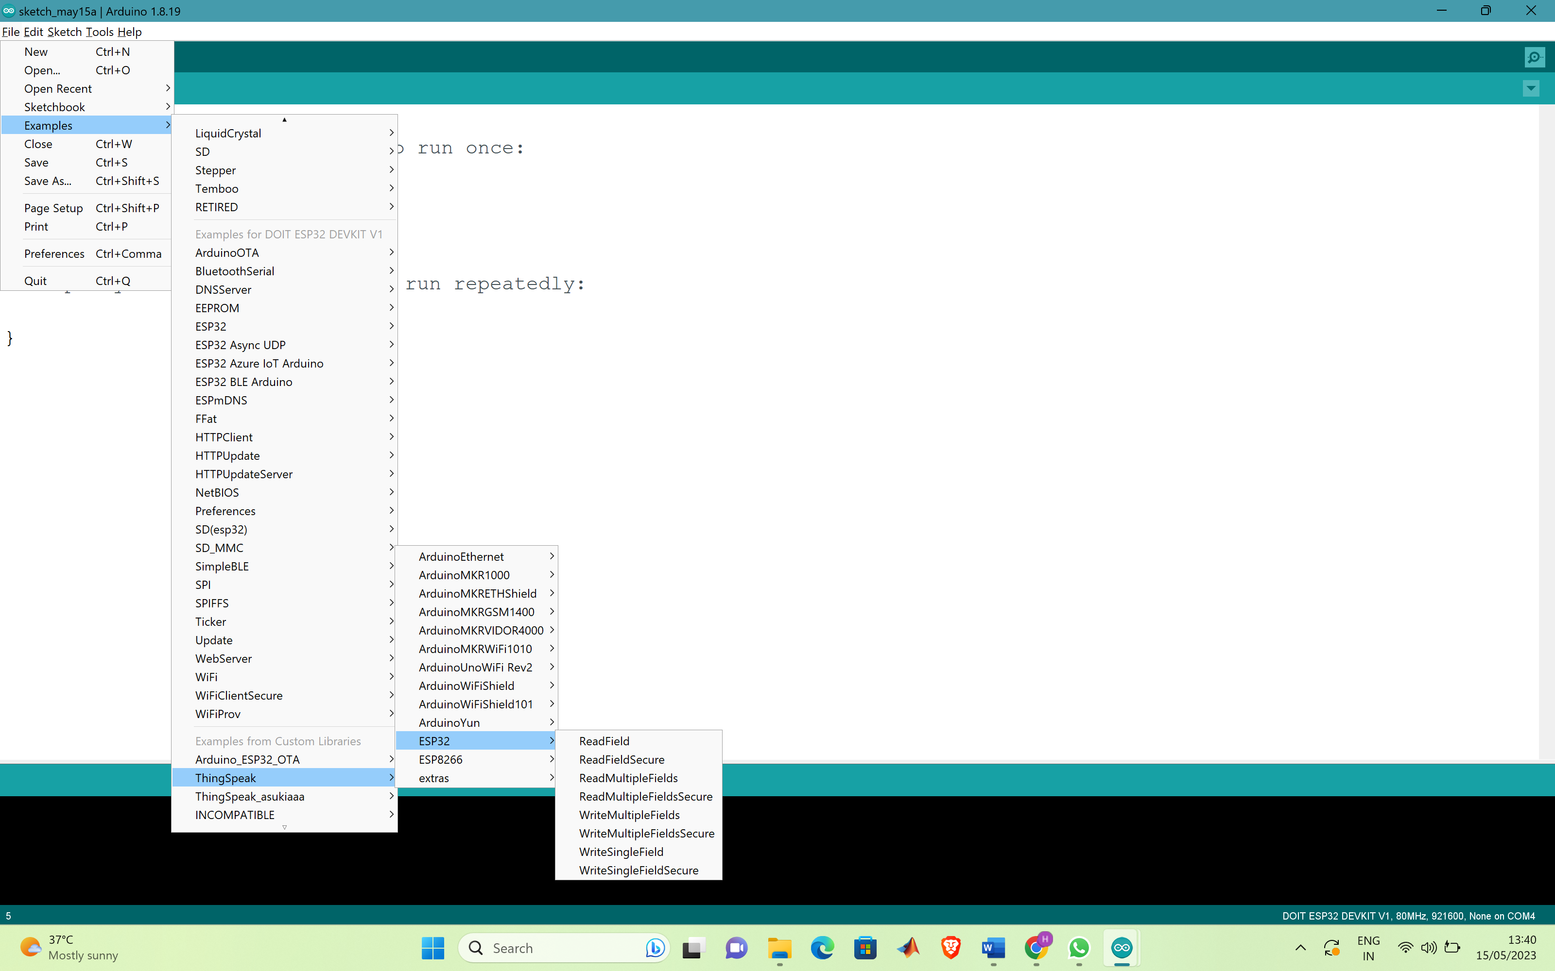

Fig 4:Inbuilt examples

### 

## ESP32

Because of its versatility, low cost, and ease of use, the ESP32 is a popular microcontroller and Wi-Fi module in the maker community. It has dual-core processors, Bluetooth and Wi-Fi connection, and a wide range of interfaces, making it appropriate for a variety of tasks. The ESP32 is distinguished by its ultra-low power consumption capabilities, which make it perfect for IoT devices that operate on battery power. It also includes an in-built security mechanism to protect against various security concerns such as replay attacks and eavesdropping. Overall, the ESP32 is a powerful microcontroller that provides a great deal of versatility for applications that require Wi-Fi connectivity, low power consumption, and security features. Because of its popularity in the maker community, there is a variety of internet resources available, including tutorials, code samples, and community assistance.

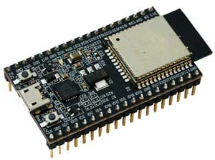

Fig 5: Esp32

**CONNECTION OF ESP32 AND WIFI**

First thing to note here is we need to use a mobile hotspot or any other wifi other than a public wifi because data cant be uploaded to ThingSpeak when it uses a public wifi. So the first thing is we should not use SASTRA wifi. Now we need to turn on mobile hotspot. We need to make sure to note the SSID and password of that respective mobile hotspot so that we can integrate it to the source code. Now comes the important step. The esp32 may be in reset mode and we may get time out error while executing. So the thing is we need to hold the reset button for some time so that the connection between esp and wifi is established successfully.

**IR SENSOR**

IR : Infrared Sensor. The role of IR sensor is to detect the objects based on infra red principle. It will produce digital output only. It has 3 pins namely VCC,GND,OUTPUT. OUTPUT pin produce 2 values 0 and 1. 0 if it detects an object and 1 if the object is not detected. Our system uses level triggering methodology. The role of IR sensor in our project is to detect the number of people entering a particular area.

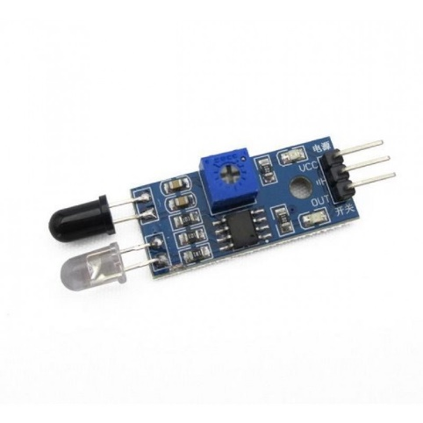

Fig 6:IR sensor

**INTEGRATING IR SENSOR AND ESP32**

GND pin of both IR sensor and esp32 is short circuited. VCC of IR sensor is given to any of the available voltage pins in the esp. We need to make sure that we should not give more than 5V to IR sensor. Output pin of the IR sensor is given to any digital pin of the esp32. Pin configuration has to be done accordingly.

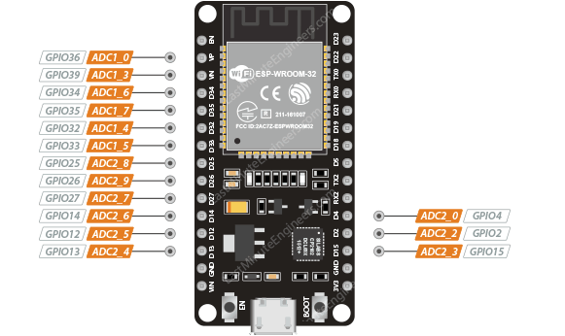

Fig 7: Pin diagram of Esp32 and IR sensor

**THINGSPEAK**

ThingSpeak is an Internet of Things (IoT) analytics platform and open API (Application Programming Interface) developed by MathWorks, a software company. It allows users to collect, analyze, and visualize data from various IoT devices and sensors in real-time.First an account on Thingspeak is created. ThingSpeak has lot of inbuilt options but we are considering only the graphical representation option and display. Inorder to upload data to Thingspeak a channel is created. There are 2 important things to be considered while creating a channel. We need to note the channel ID and API key of our channel. Both are unique numbers.These both should be integrated into the code.These are the important parameters which are to considered while uploading the data to ThingSpeak.

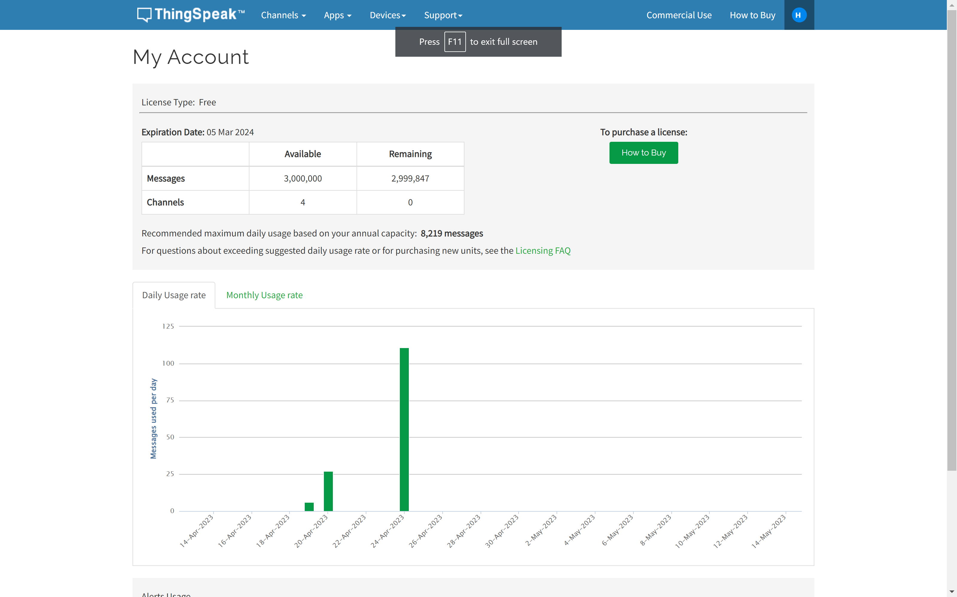

Fig 8:Account section

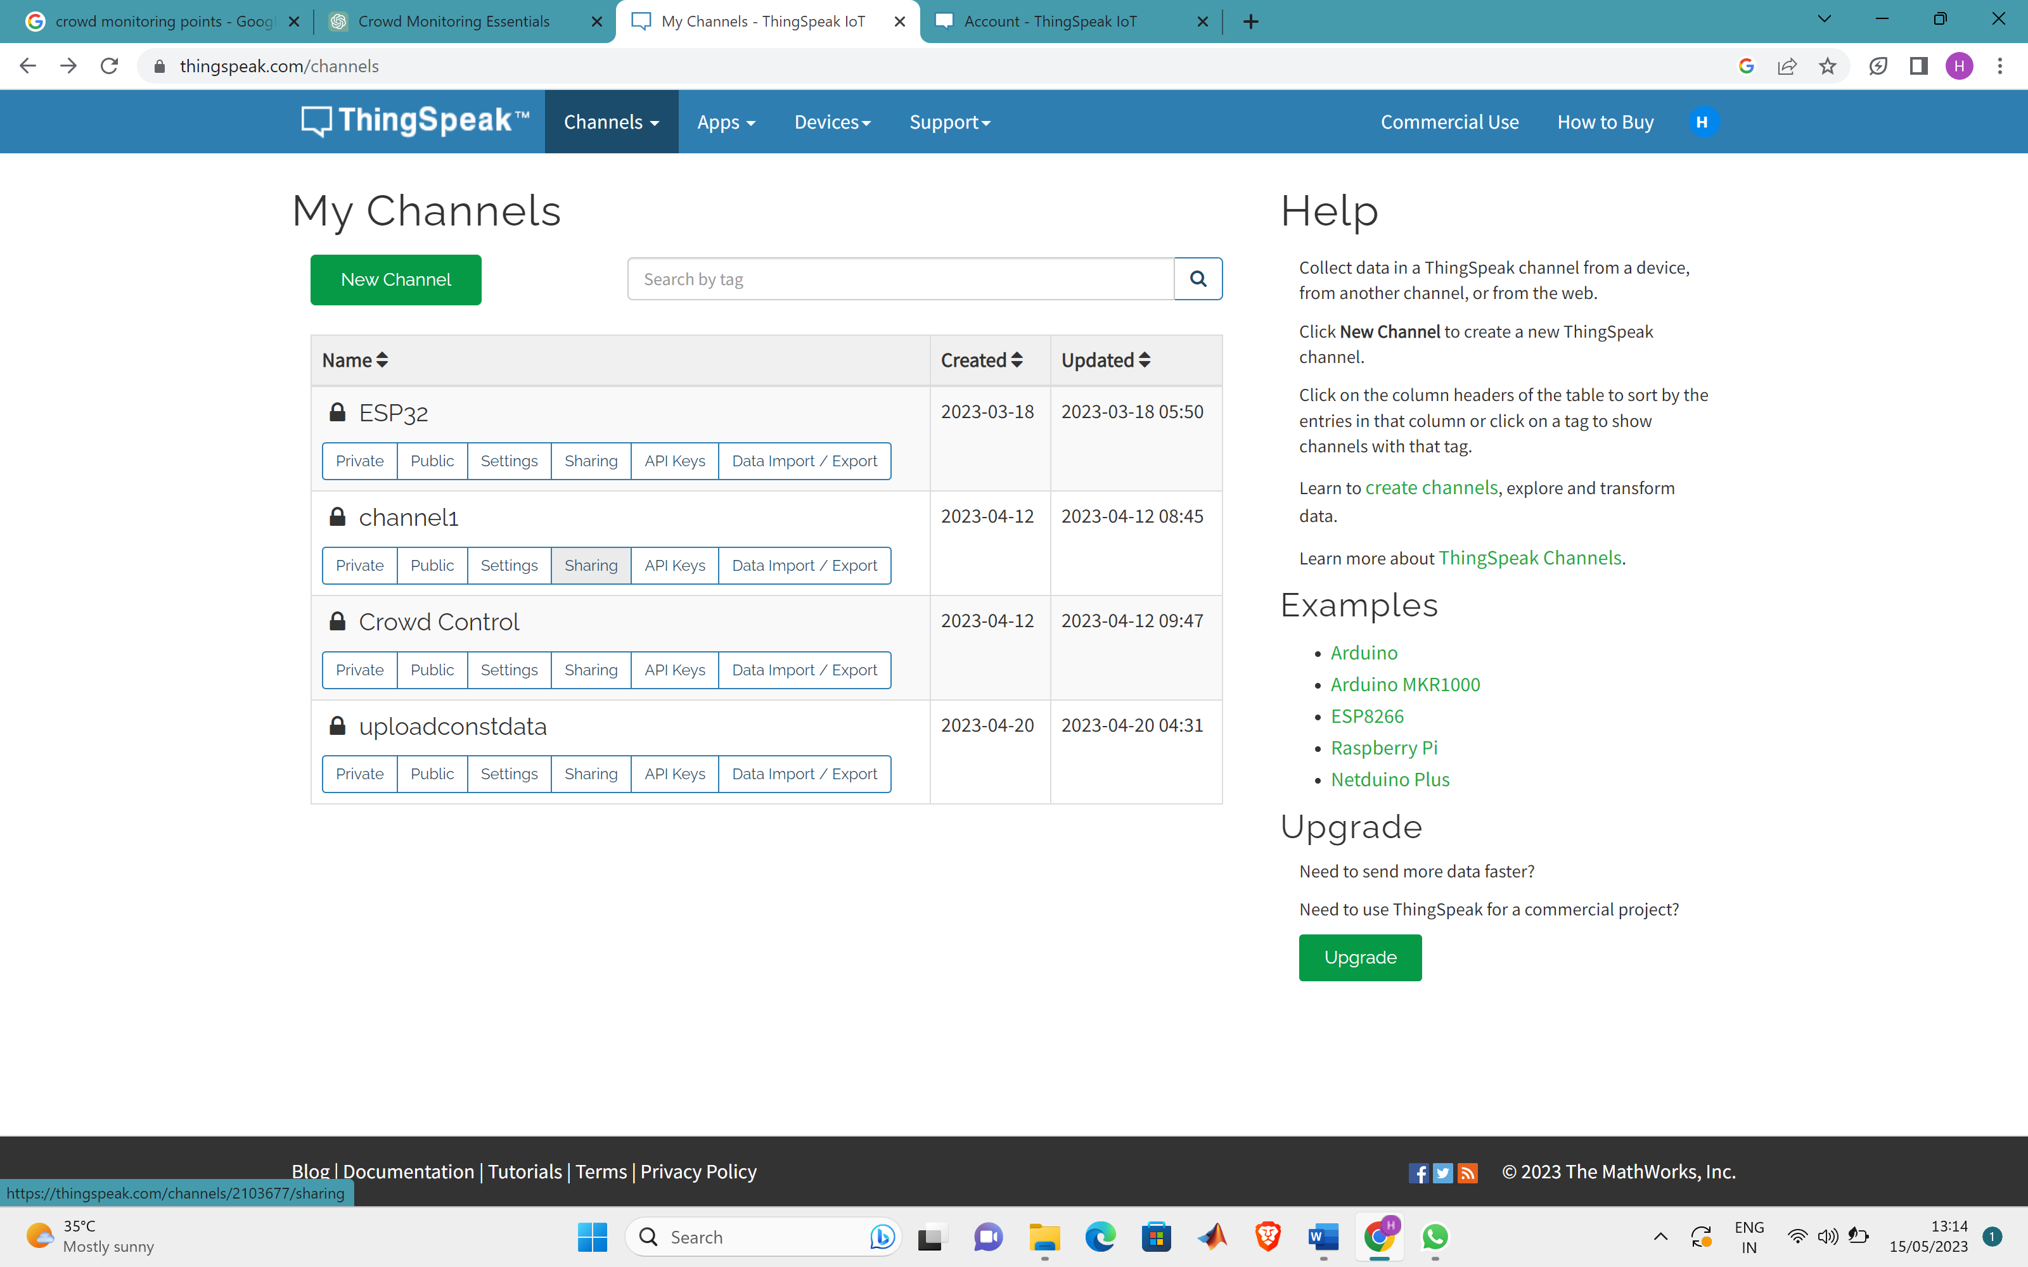

Fig 9: Channels in ThingSpeak

**INTEGRATING THINGSPEAK WITH ESP AND IR SENSOR**

The noted channel ID and API Key should be integrated with wifi credential and we need to make sure that the pins are properly configured in accordance with the pins we use in esp32 and IR sensor respectively. Again to ensure the smooth functioning of the system the reset button of the esp32 should be held for few seconds.After this the data will be uploaded to Thingspeak smoothly.

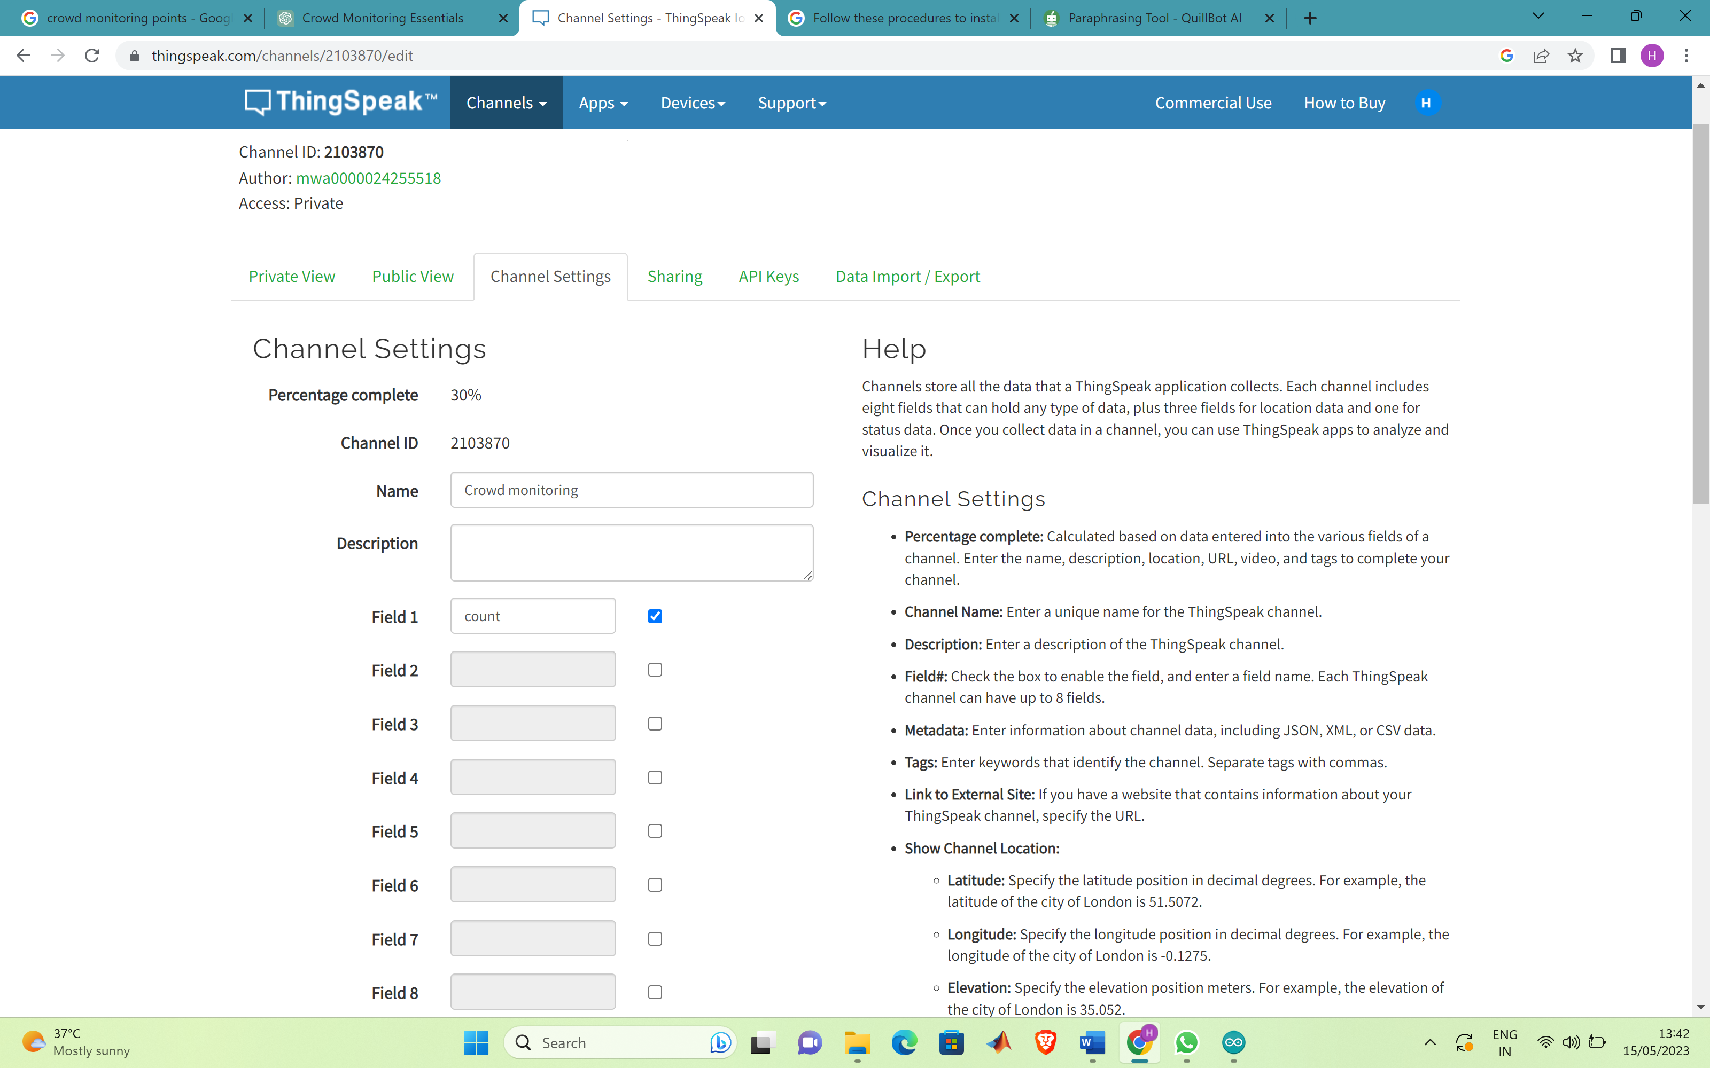

Fig 10:Channel Id

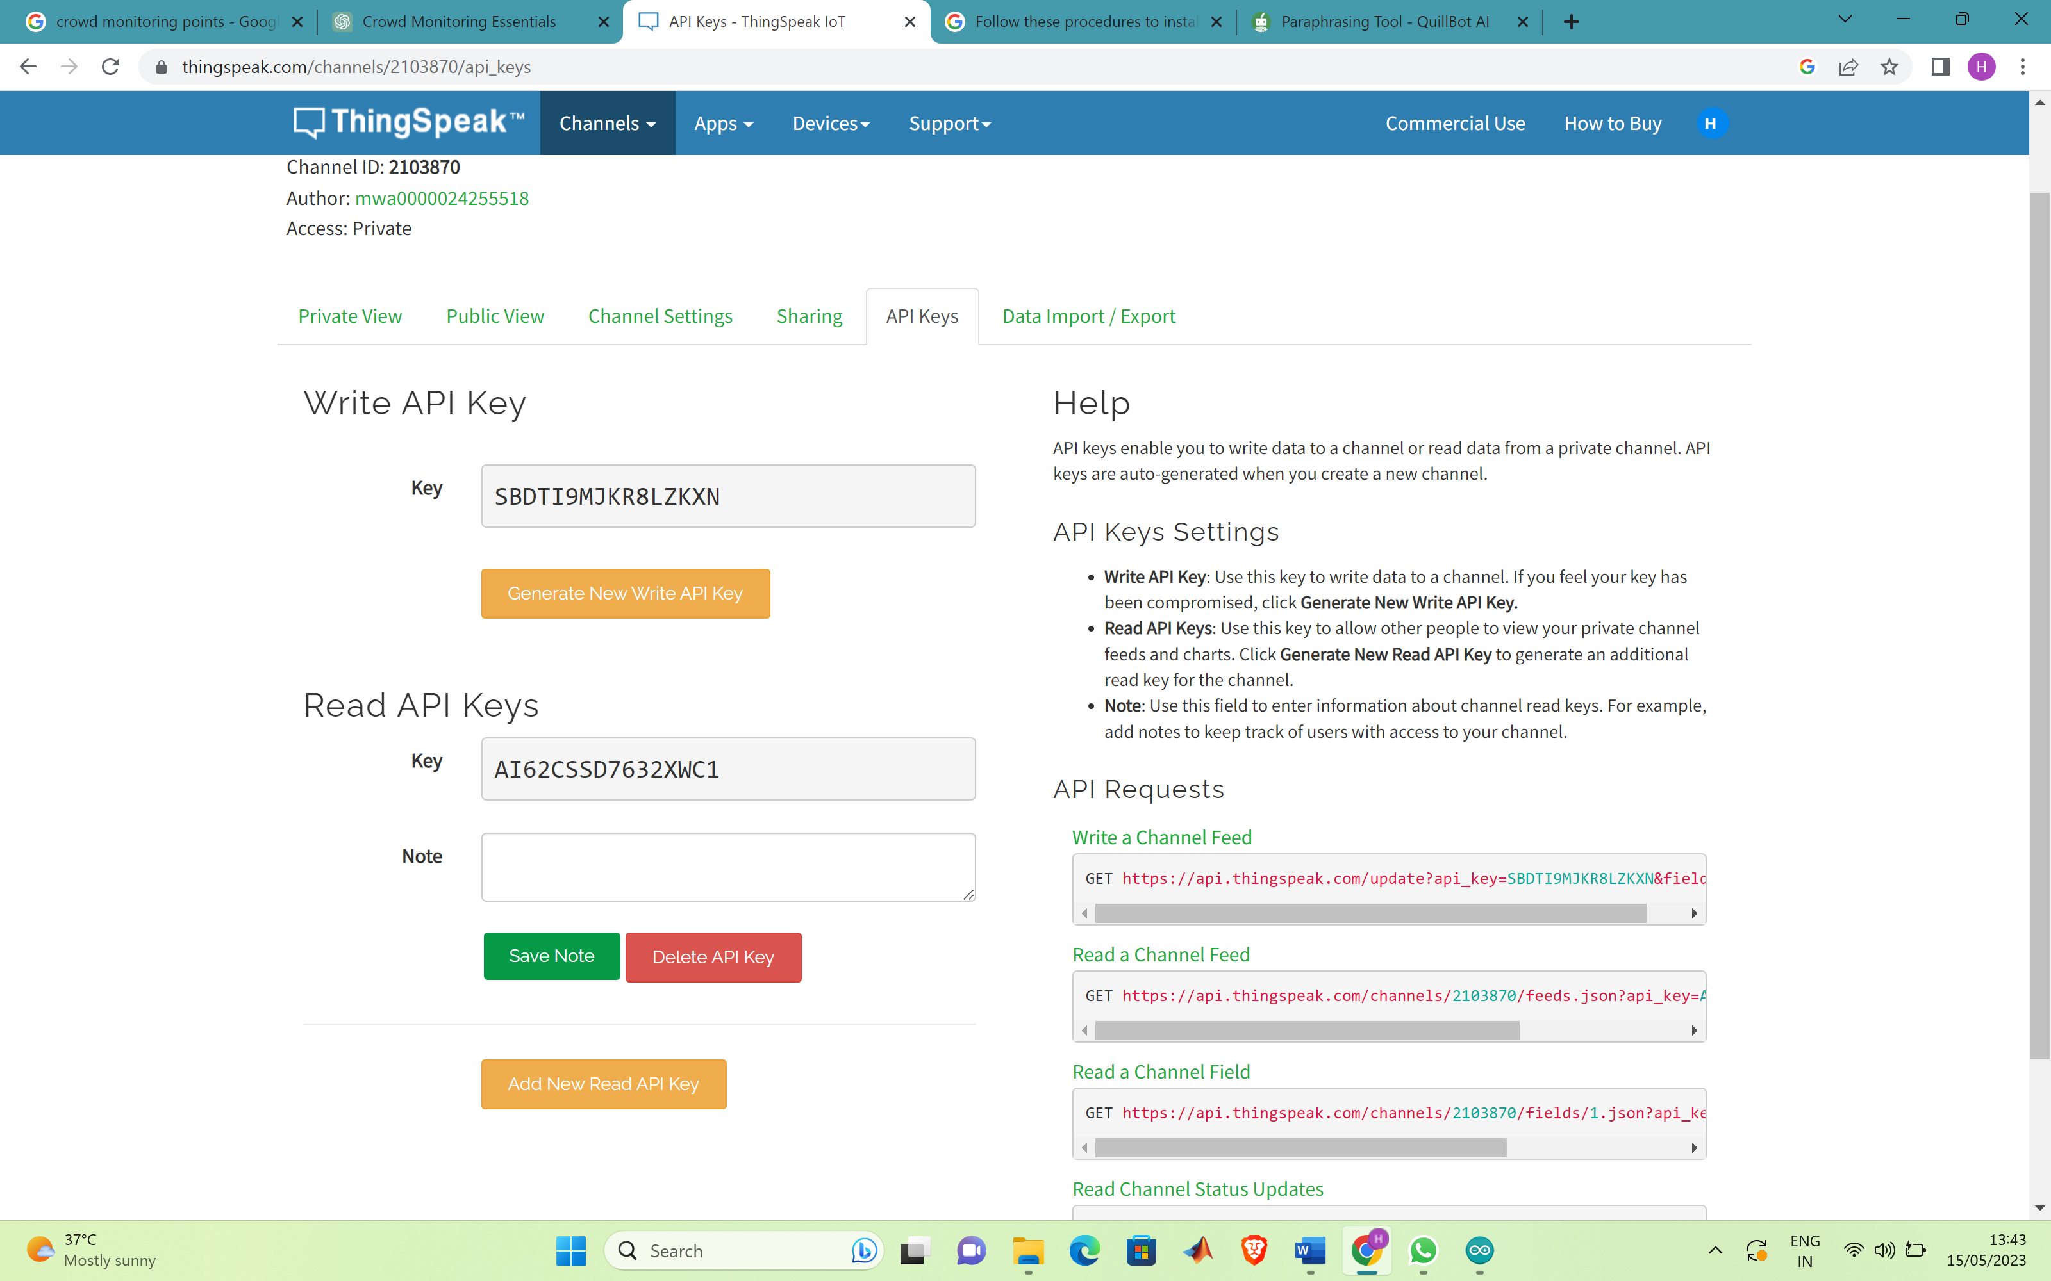

Fig 11: API key

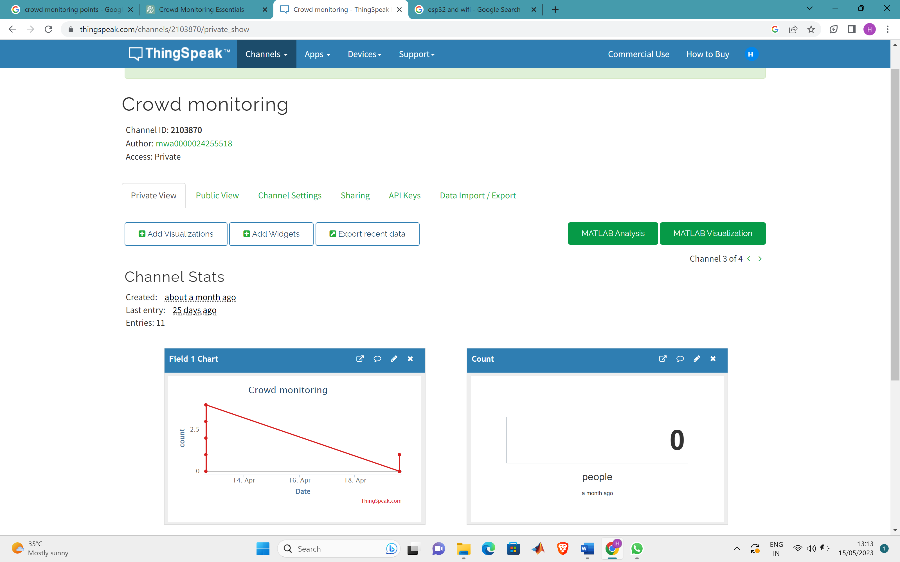

Fig 12:Private view

To summarize ThingSpeak provides a robust and user-friendly framework for gathering, analyzing, and visualizing IoT data. Its capabilities, such as real-time analytics, data storage, and visualization choices, enable users to make sense of the massive amounts of data created by IoT devices and sensors. The open API and connections with other IoT systems increase its versatility and capabilities, enabling seamless connectivity and interoperability. The community-driven approach of ThingSpeak encourages collaboration and knowledge exchange among IoT enthusiasts and professionals, resulting in creative applications and solutions. ThingSpeak streamlines the process of harnessing IoT data, empowering users to draw useful insights and make educated decisions, whether for personal projects or industrial applications. ThingSpeak continues to contribute to the evolution of technology with its user-friendly interface and broad capabilities.

**OUTPUT**

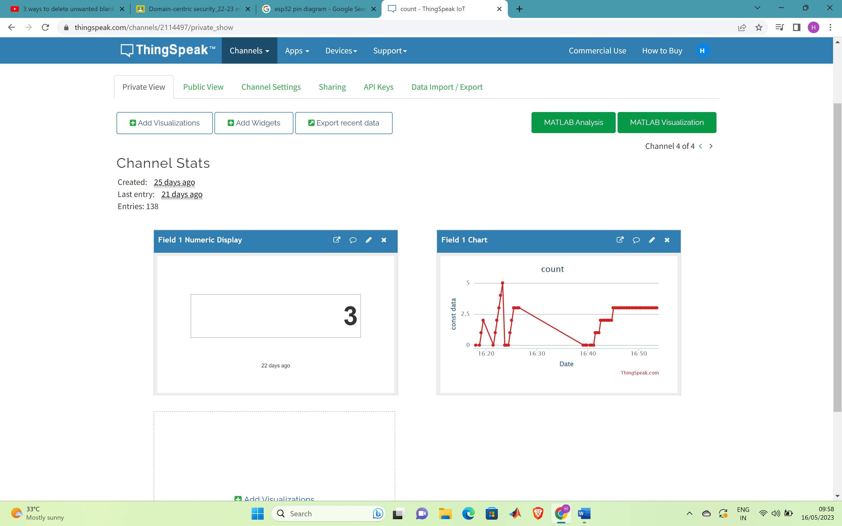

Fig 13:Output (3 people detected)

Here the observation is that there were 3 people detected t the time of checking the database. 3 is displayed in the numeric display. Also there is a graph which provides the count of people at different time instances.

**CONCLUSION**

Finally, crowd control monitoring is critical in guaranteeing the safety, security, and efficient administration of huge crowds. Crowd monitoring enables authorities to identify possible problems, respond quickly to emergencies, and optimize crowd flow by utilizing innovative technologies, real-time analytics, and proactive techniques. It gives useful insights for event organizers, city planners, and public safety organizations, allowing for more effective resource allocation and preparedness. However, it is critical to strike a balance between the necessity for crowd surveillance and privacy concerns and ethical practices. For the continuous improvement of crowd control monitoring systems, continuous evaluation, collaboration, and the development of best practices are required. Overall, crowd control monitoring is an important technique for protecting public safety and establishing a safe atmosphere for individuals.